Understanding Classes in JavaScript

**Key Components of JavaScript Classes**

1. **Class Definition**: A class in JavaScript is defined using the class keyword. This provides a clear and concise syntax to create classes and manage objects.
2. **Constructor Method**: The constructor is a special method for creating and initializing an object created with a class. There can only be one special method with the name constructor in a class. If a class does not have a constructor, a default one is provided automatically.
3. **Instance Methods**: These are methods defined inside a class that are meant to be called on instances of the class.
4. **Static Methods**: These are methods defined with the static keyword and can be called directly on the class itself, not on instances of the class.
5. **Inheritance**: Classes can extend other classes using the extends keyword. The super keyword is used to call the constructor of the parent class.
6. **Encapsulation**: While JavaScript does not enforce strict encapsulation, ES2020 introduced private fields and methods with the # prefix to achieve true private properties and methods.

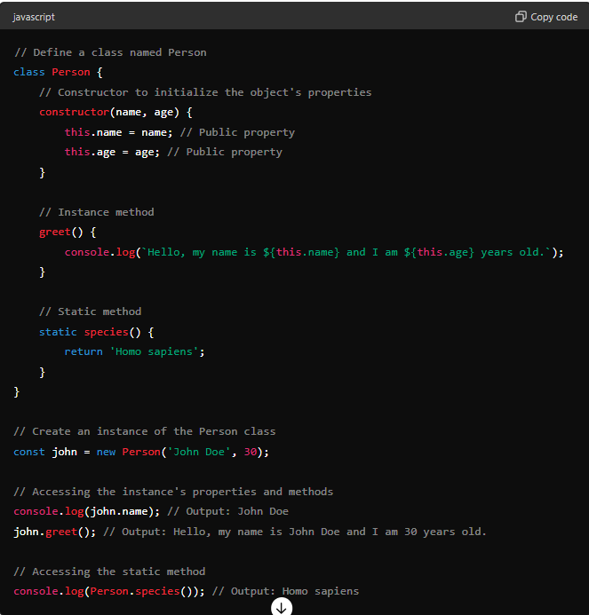

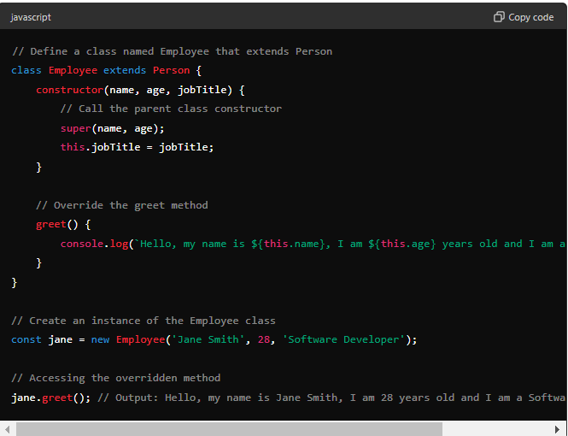

greet() { console.log(`Hello, my name is ${this.name}, I am ${this.age} years old and I am a ${this.jobTitle}.`); }

#### Private Fields and Methods

Private fields and methods are denoted by a # prefix and are only accessible within the class they are defined in. This feature helps achieve true encapsulation.

